**SPRINT-3**

DASHBOARD

|  |  |
| --- | --- |
| Date | 16-11-2022 |
| Team ID | PNT2022TMID24269 |
| Project Name | Estimate the Crop Yield Using Data Analytics |

LINK:

https://us3.ca.analytics.ibm.com/bi/?perspective=dashboard&pathRef=.public _folders%2FCrop%2BYield%2BEstimation%2FMain%2BDashboard&action=vie w&mode=dashboard&subView=model0000018470384987_00000000

# DASHBOARD 1

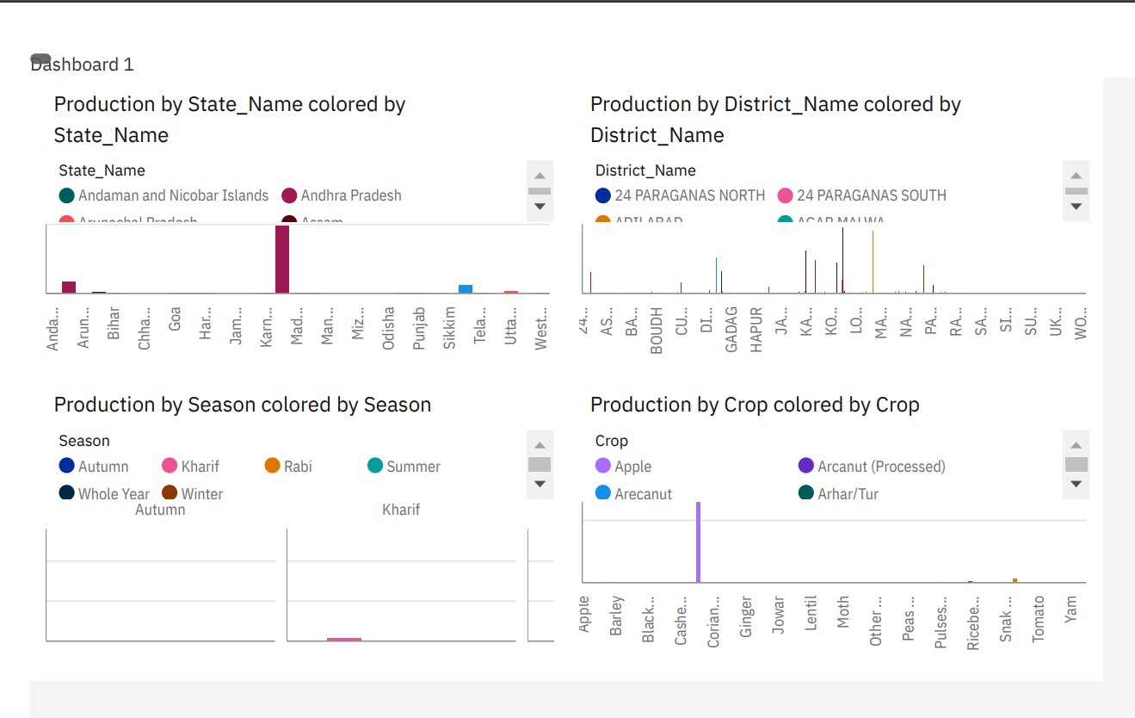

# DASHBOARD 2

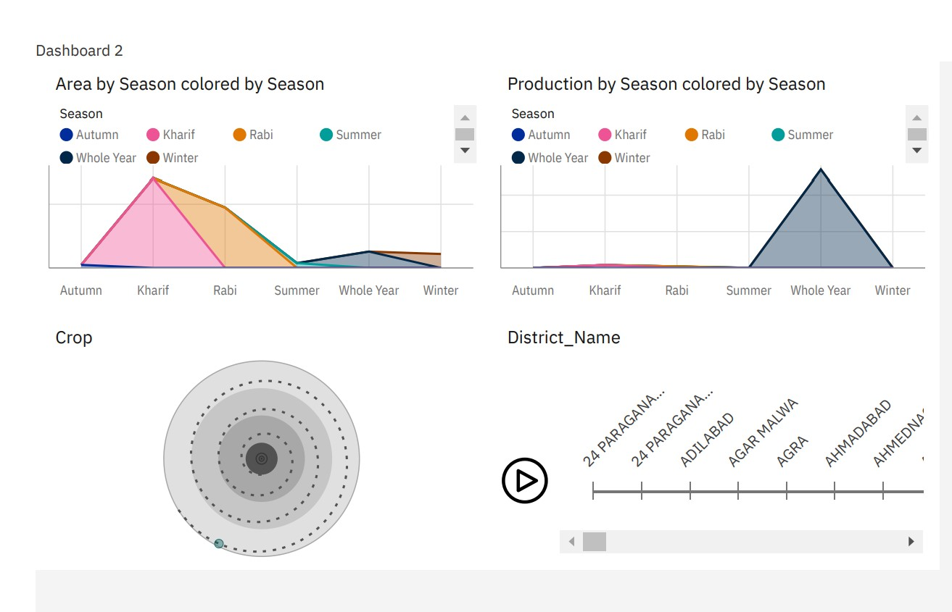

# DASHBOARD – 3

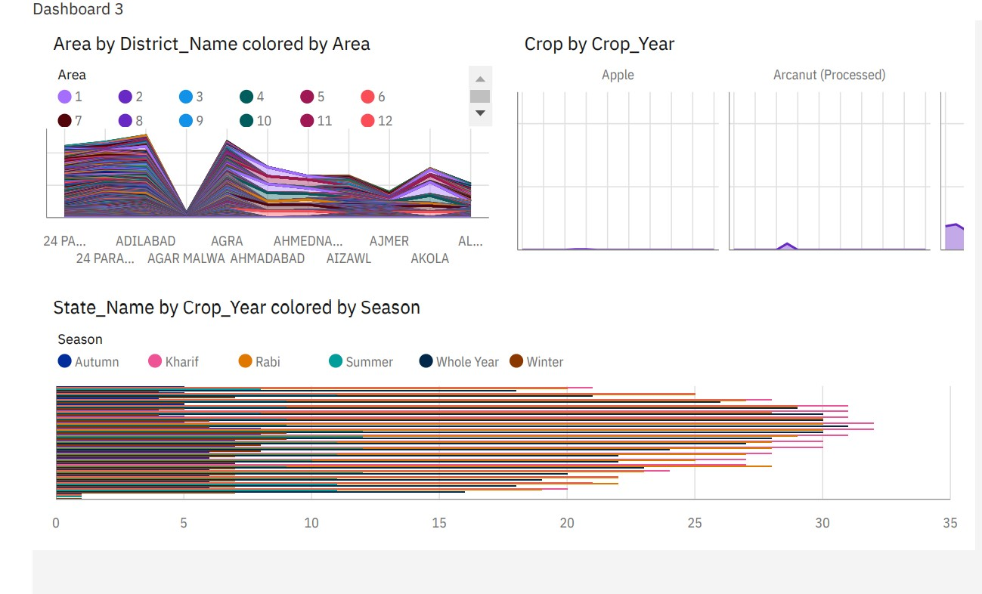

**DASHBOARD 4**

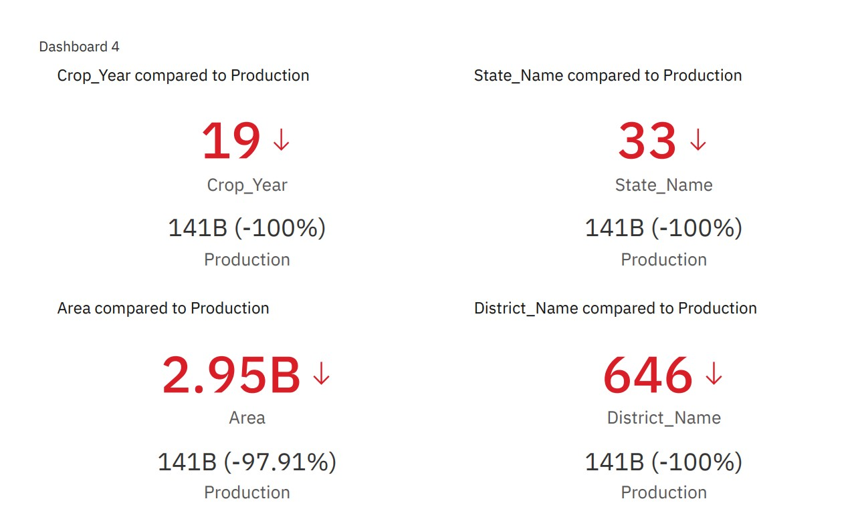

**DASHBOARD 5**

